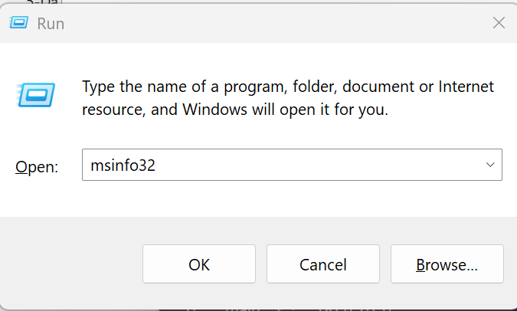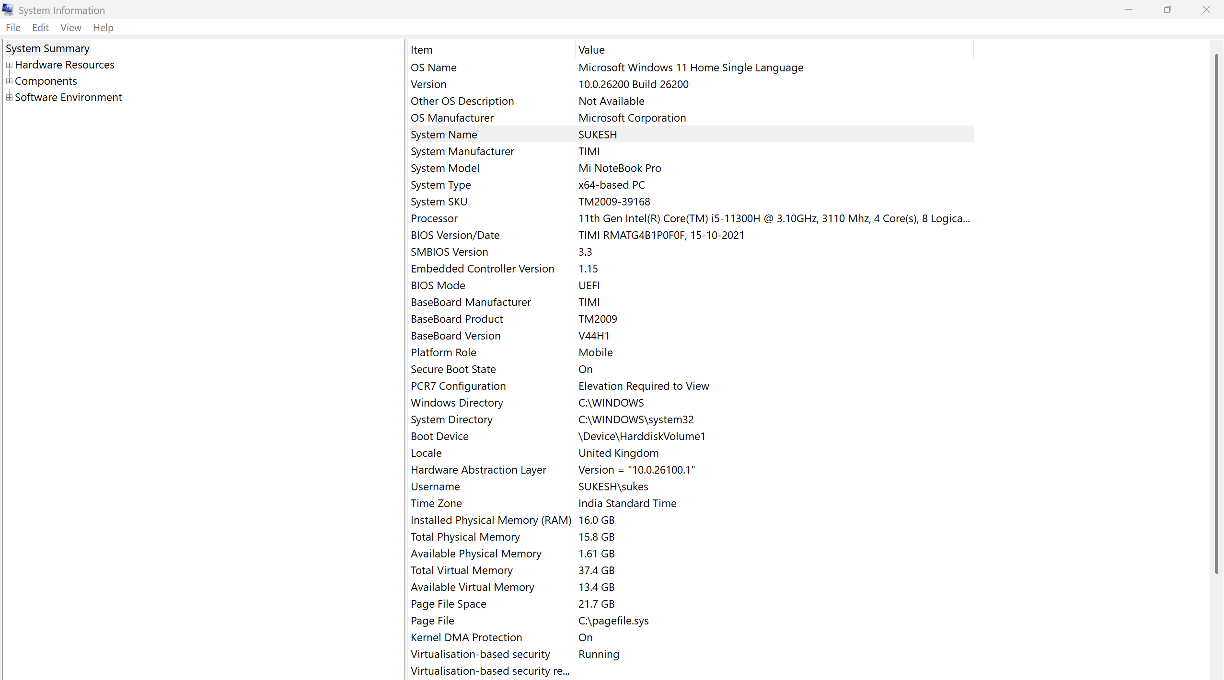

How to Open msinfo32 (System Information)
Using Run Command
- Press Windows Key + R on the keyboard.
- The Run dialog box will appear.
- Type:
msinfo32
- Press Enter.
- The System Information window will open.
System Summary
The System Summary page gives an overview of the entire computer.
Important fields to explain:
OS Name and Version
Shows the installed operating system and build number.
Used to verify update level and compatibility.
System Manufacturer and Model
Identifies the laptop or desktop model.
Useful for driver downloads and hardware identification.
System Type
Example: x64-based PC.
Indicates whether the system is 64-bit or 32-bit.
Processor
Displays CPU model, speed, cores, and logical processors.
Teaching point:
- Difference between cores and threads.
Installed Physical Memory (RAM)
Total RAM installed in the system.
Available Physical Memory
Shows how much RAM is free at the moment.
BIOS Version and BIOS Mode
Indicates firmware version and whether the system uses UEFI or Legacy BIOS.
Secure Boot State
Shows whether secure boot is enabled.

